IST 736 Text Mining

**Mining Insights from Cancer Related Discussions – A Text Mining Approach**

Final Project Report



**Group Members:**

Chinmay Maganur

Saikumar Pochireddy

Shubh Mody

**Introduction**

In this project, the focus is on analyzing cancer-related discussions on Reddit. Reddit, being a popular platform for community discussions, hosts various subreddits where individuals share their experiences, concerns, and information about cancer. These discussions can range from personal stories of battling cancer and seeking advice on diagnosis and treatment, to sharing emotional support and experiences with different types of cancers. By analyzing these discussions, valuable insights can be gleaned about the concerns and perspectives of those affected by cancer. This analysis can help in understanding the common themes, sentiments, and trends in these online communities, providing a unique window into the collective experiences and perceptions surrounding cancer.

**About Data:**

Data can be found here: <https://atlantis.ischool.syr.edu/share/reddit/cancer/>

We worked on Testicular cancer data that had two files submission and comments . We merged both the file to get final file.

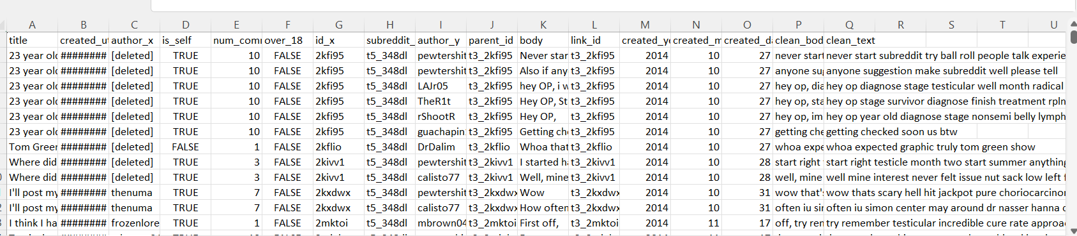

**Basic Analysis**

**Author Contributions:**

A bar chart delineates the volume of content generated by individual authors within the dataset. This visualization ranks authors based on the quantity of their contributions to cancer-related posts. It is an effective tool for identifying the most active members within the community, thereby recognizing those whose insights and inputs are most prevalent.

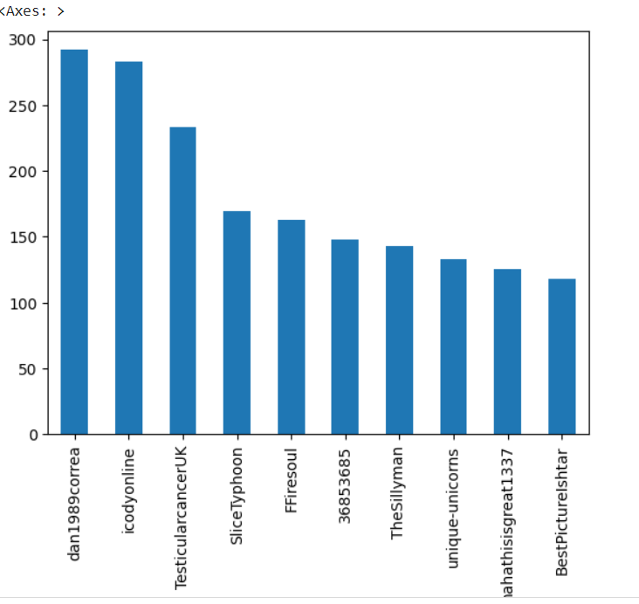

**Temporal Distribution of Posts:**

The dataset was analyzed to reveal the distribution of posts over a timeline from 2014 to 2022. The resulting bar graph indicates an increasing trajectory in the number of posts over the years. This trend suggests a growing engagement in online platforms regarding cancer discussions or could possibly reflect the evolving public interest and awareness related to cancer.

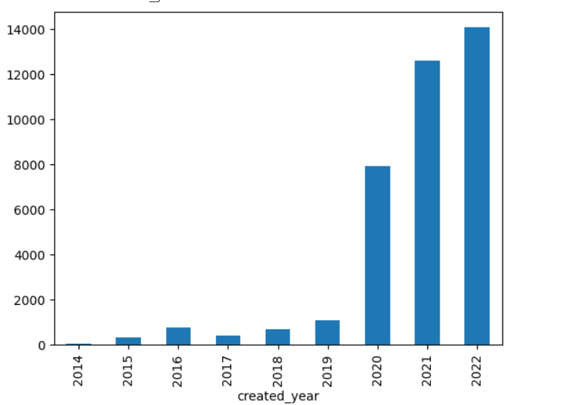

**Word Cloud of Uncleaned Data**:

Prior to data cleaning, a word cloud was generated to visualize the frequency of terms within the unfiltered dataset. This graphic representation underscores the most prominent terms, with size correlating to frequency. The word cloud serves as an intuitive method for rapidly identifying dominant themes and topics before the refinement of data.

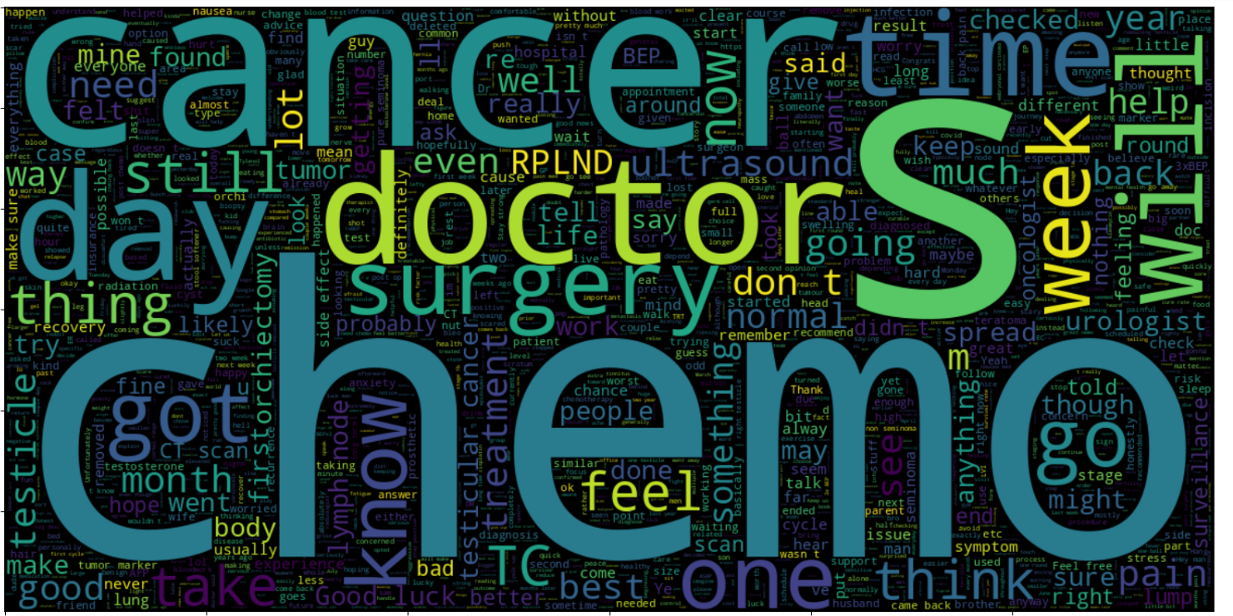

**Data Cleaning**

1. Removing Stop Words: We took out common words like "is," "and," "the," etc., because they don't add much meaning and are not useful for our analysis.
2. Removing Non-Alphabets: We got rid of anything that's not a letter, like numbers, symbols, and punctuation marks, to focus just on words.
3. Lemmatization: We changed words to their root form. For example, "living" or "alive" becomes "live." It helps us treat different forms of the same word as one.
4. Converting to Lowercase: We made all the letters small (lowercase) so that words like "Cancer" and "cancer" are treated the same.
5. Tokenization: We split the text into individual words so we can work with each word separately.

**Emotion Classification Analysis**

One of the project objectives was to develop an emotion classifier capable of interpreting and categorizing textual data by the conveyed emotion. The classifier was trained and evaluated to distinguish between six core emotions: sadness, joy, love, anger, fear, and surprise.

A dataset comprising textual excerpts was collated, with each entry meticulously labeled with an emotion identifier. This dataset formed the foundation for training the classifier.

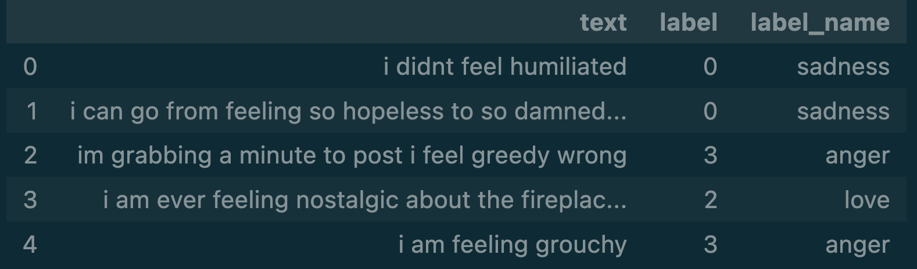

Model Training and Evaluation:

We employed multiple classification algorithms, including Logistic Regression and Gaussian Naive Bayes (G MNB). Subsequently, a model refinement process was undertaken, resulting in a fine-tuned model with optimized parameters for enhanced performance.

**Results**

**Distribution of Emotions:**

The initial analysis involved examining the frequency of each classified emotion. Joy was the predominant emotion, followed by sadness and love, as depicted in the dataset's bar chart distribution.

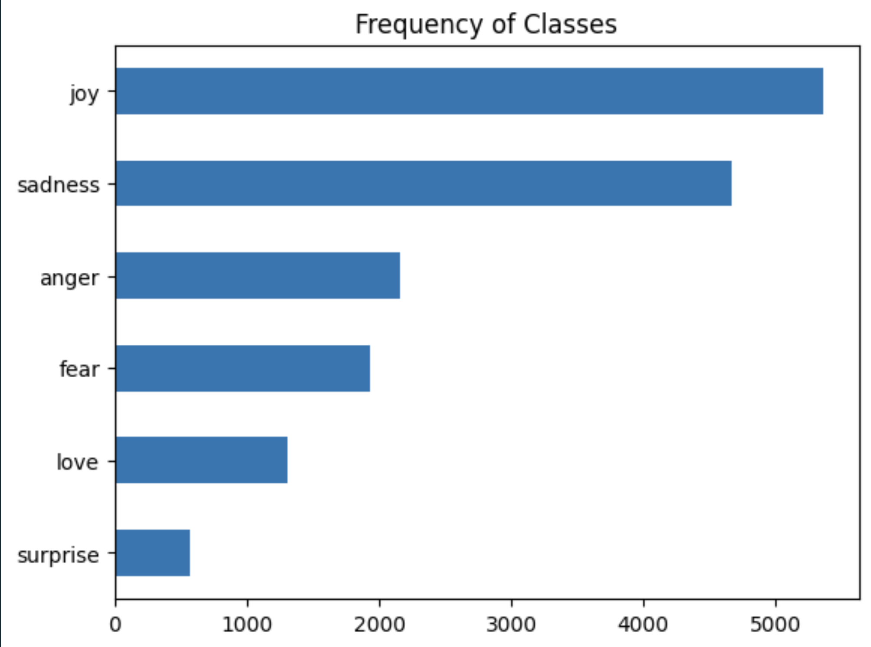

**Confusion Matrix Evaluation:**

The performance of the Logistic Regression and Gaussian Naive Bayes models was assessed using normalized confusion matrices. These matrices revealed the proportion of true positive predictions against the total predictions. While Logistic Regression demonstrated proficiency in classifying joy, sadness and fear, it underperformed in accurately identifying love, anger and surprise. Conversely, the Gaussian Naive Bayes model presented a more balanced accuracy across emotions, although with a generally lower correct classification rate.

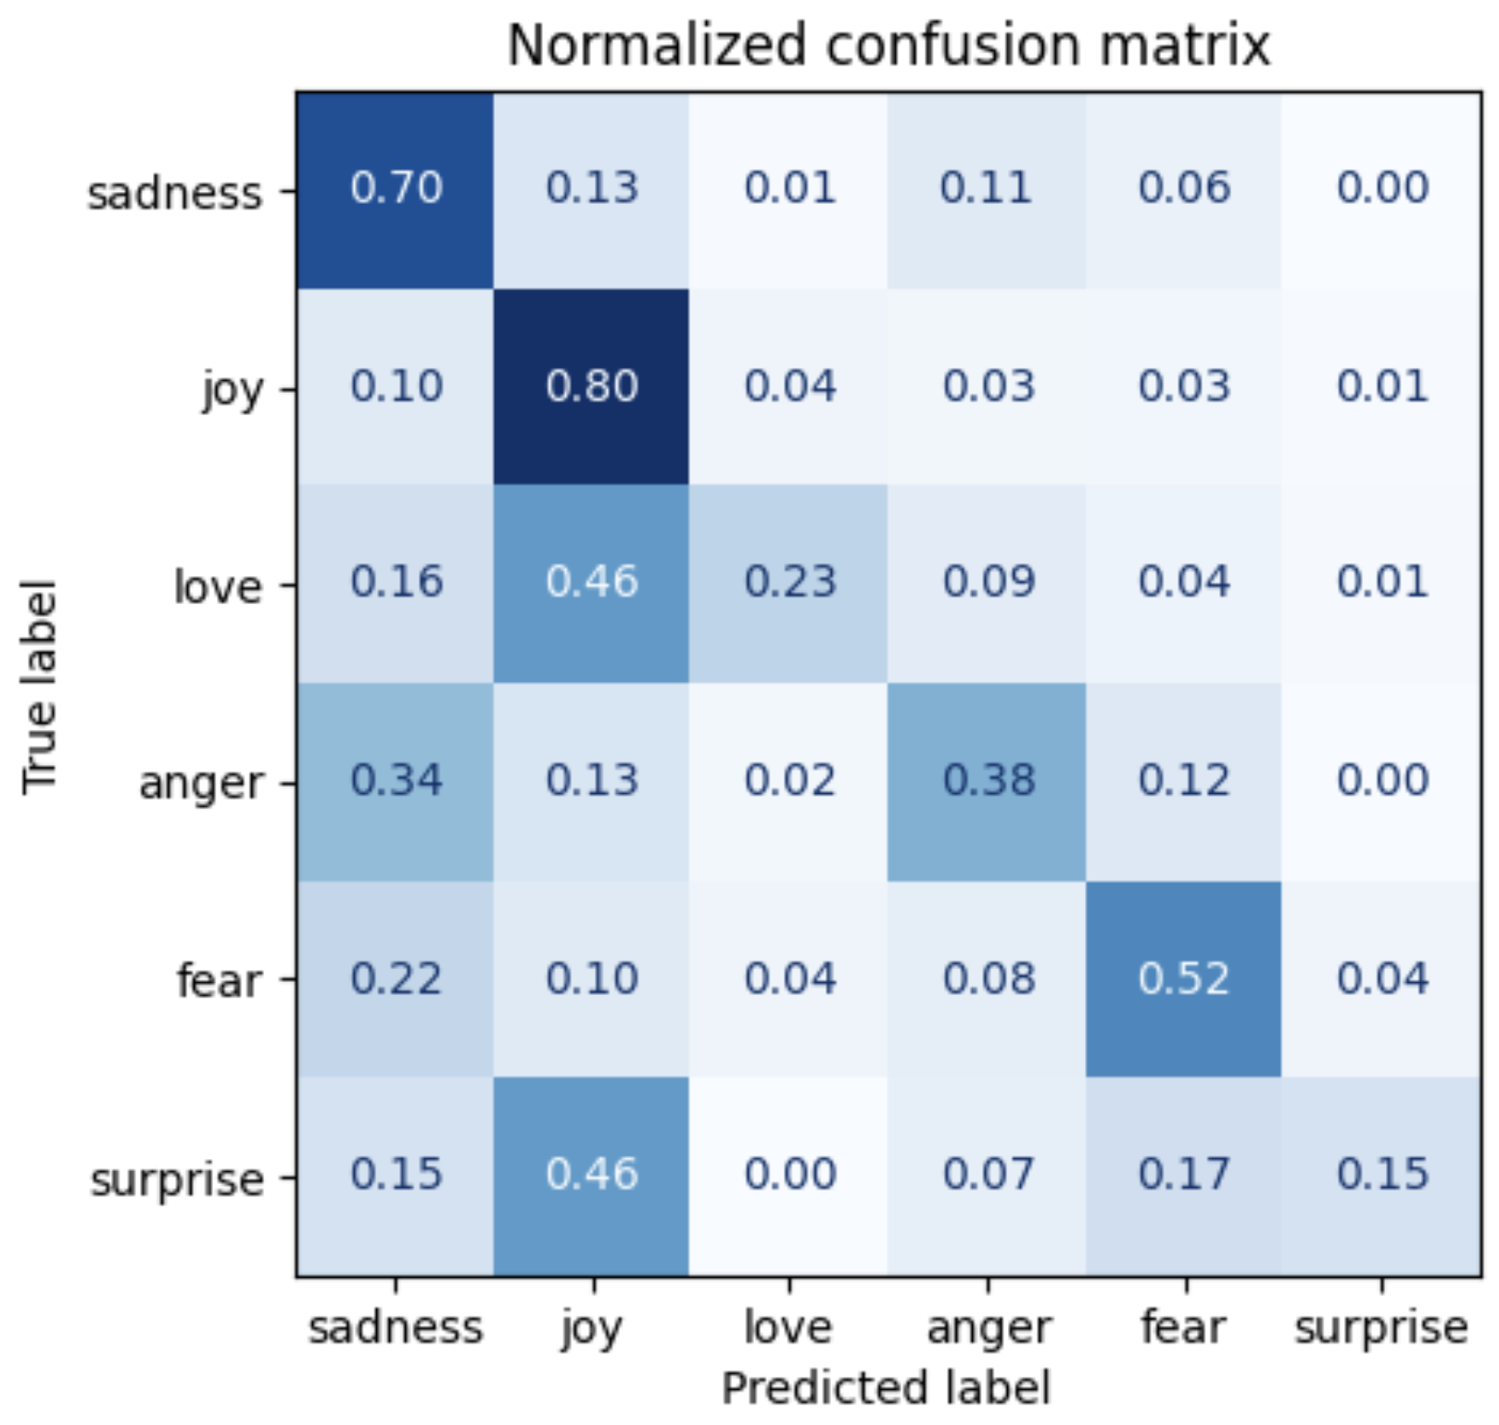 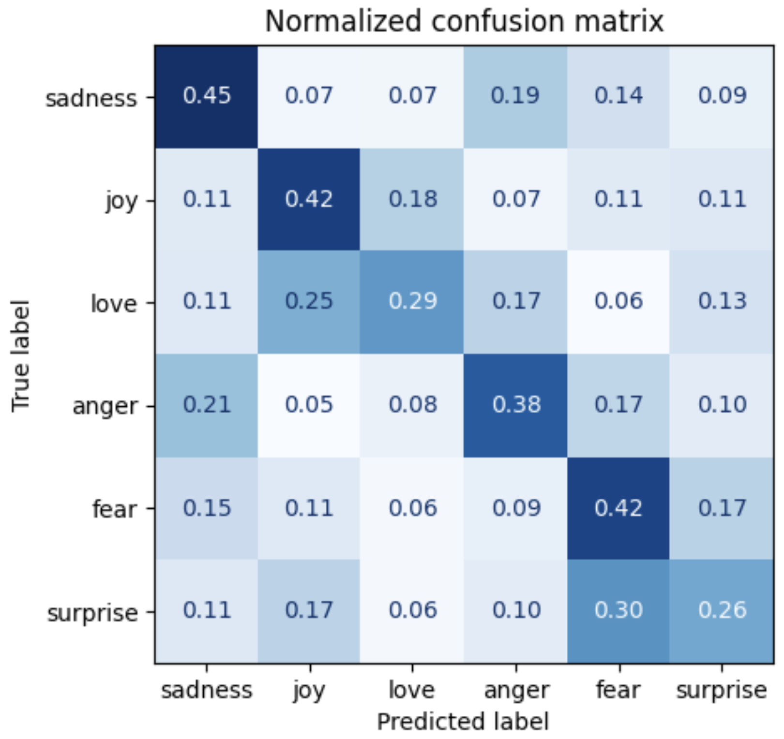

Logistic Regression G MNB

**Fine-Tuned Model Performance:**

A significant enhancement in the classification accuracy was observed with the fine-tuned model. The confusion matrix for this model exhibited an elevated rate of correct predictions across all emotions, indicating a robust improvement over the preliminary models.

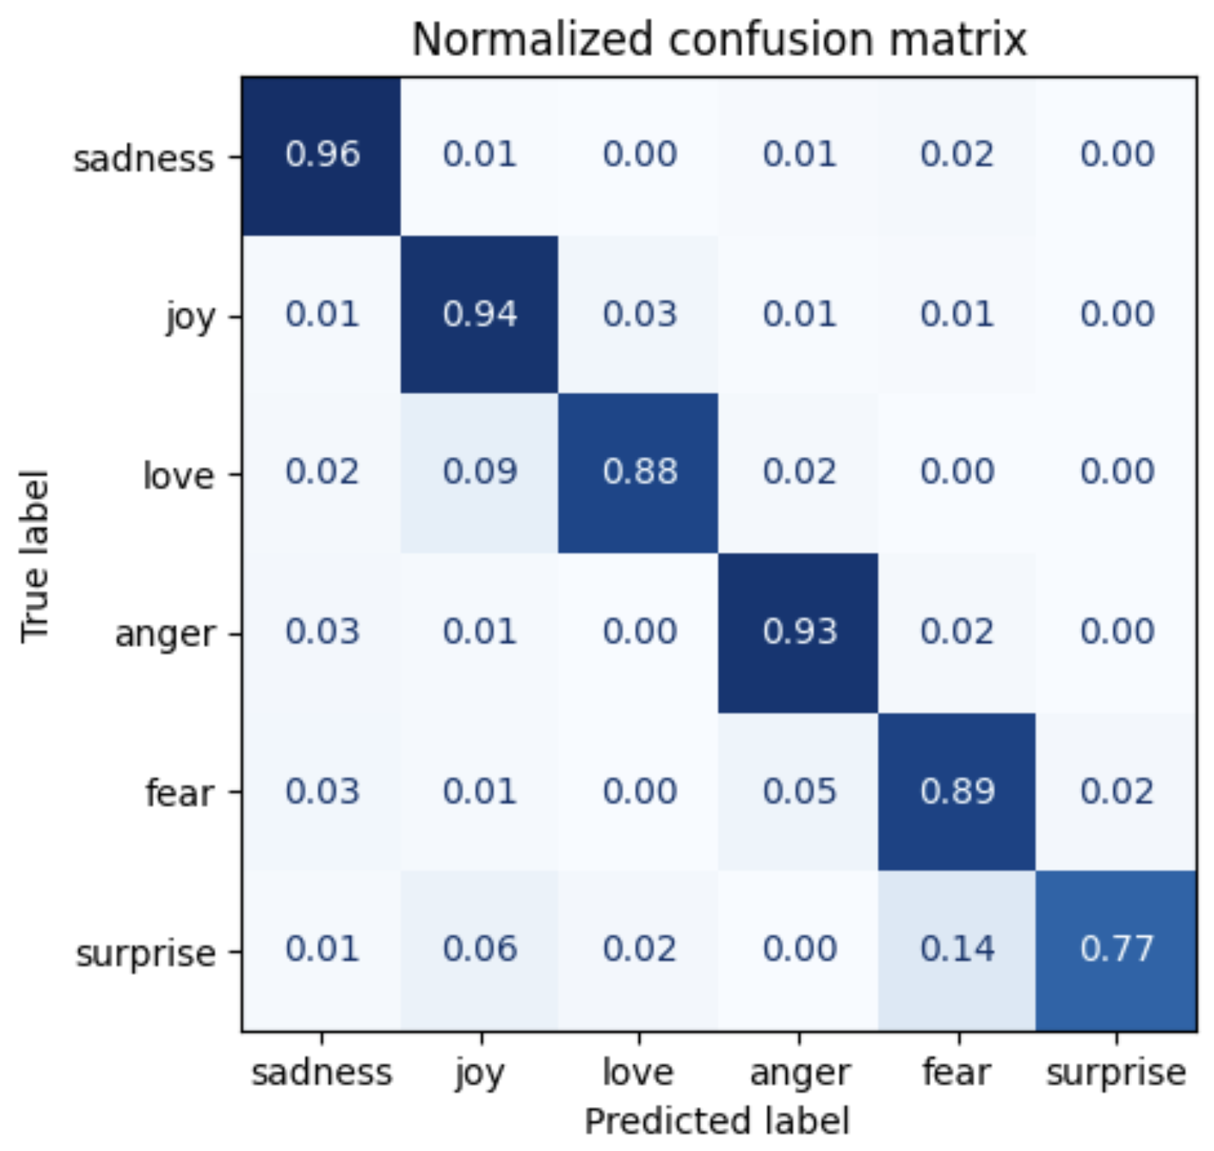

**Prediction Visualization:**

To visually interpret the models' performance, scatter plots were generated, representing the clustering of data points by predicted emotions. The fine-tuned model's plots demonstrated clear and defined clustering, implying a superior ability to differentiate between emotions compared to the other models.

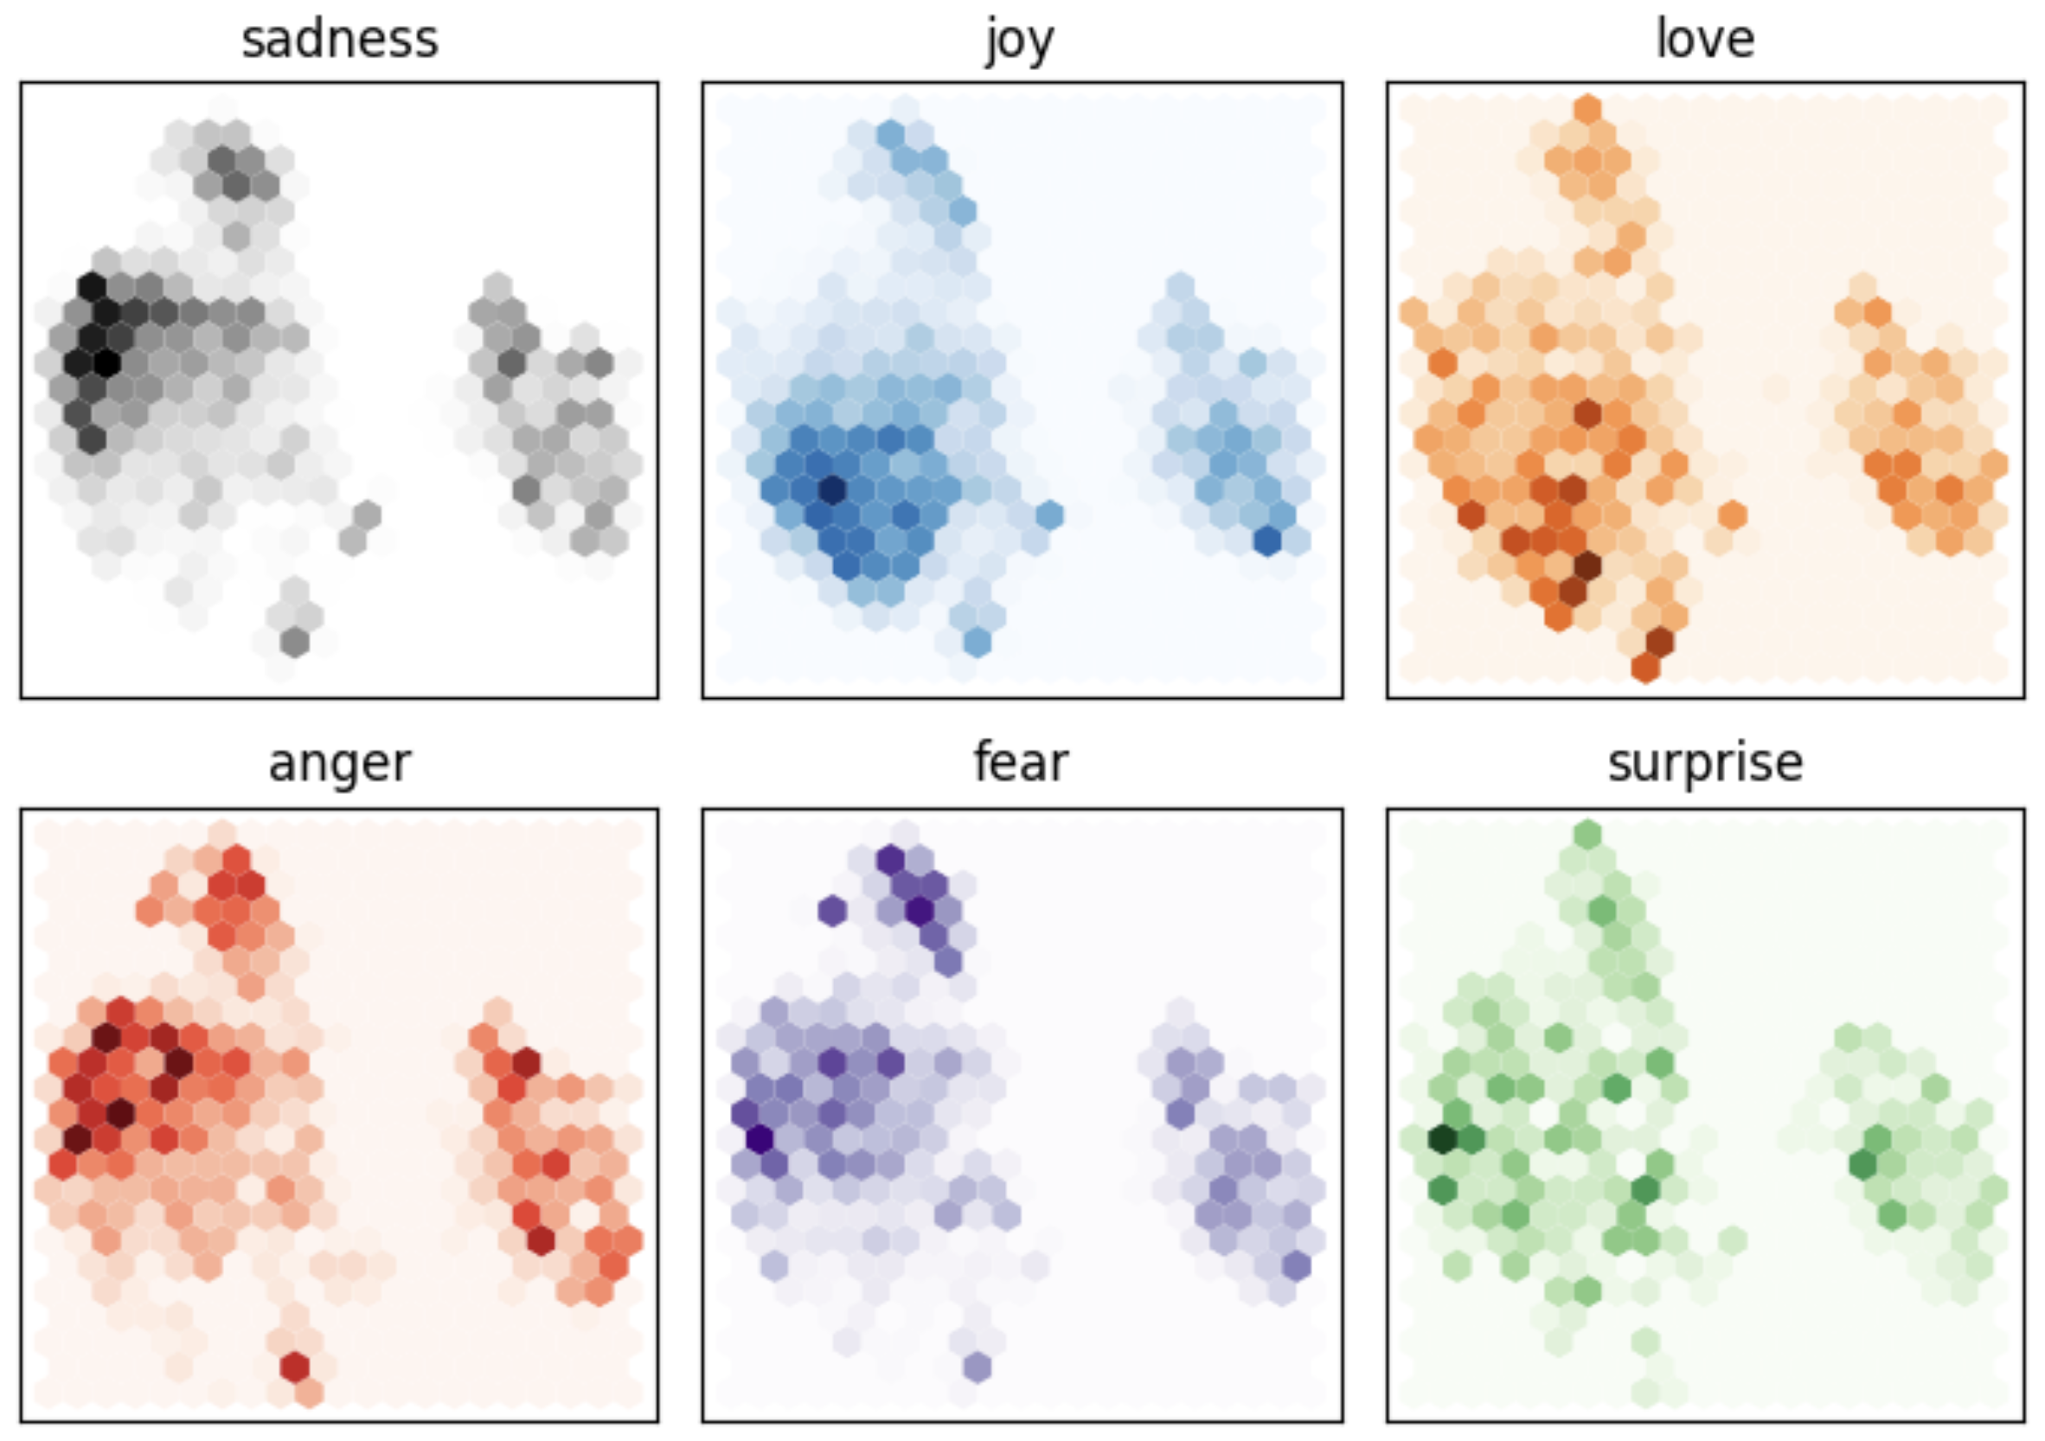 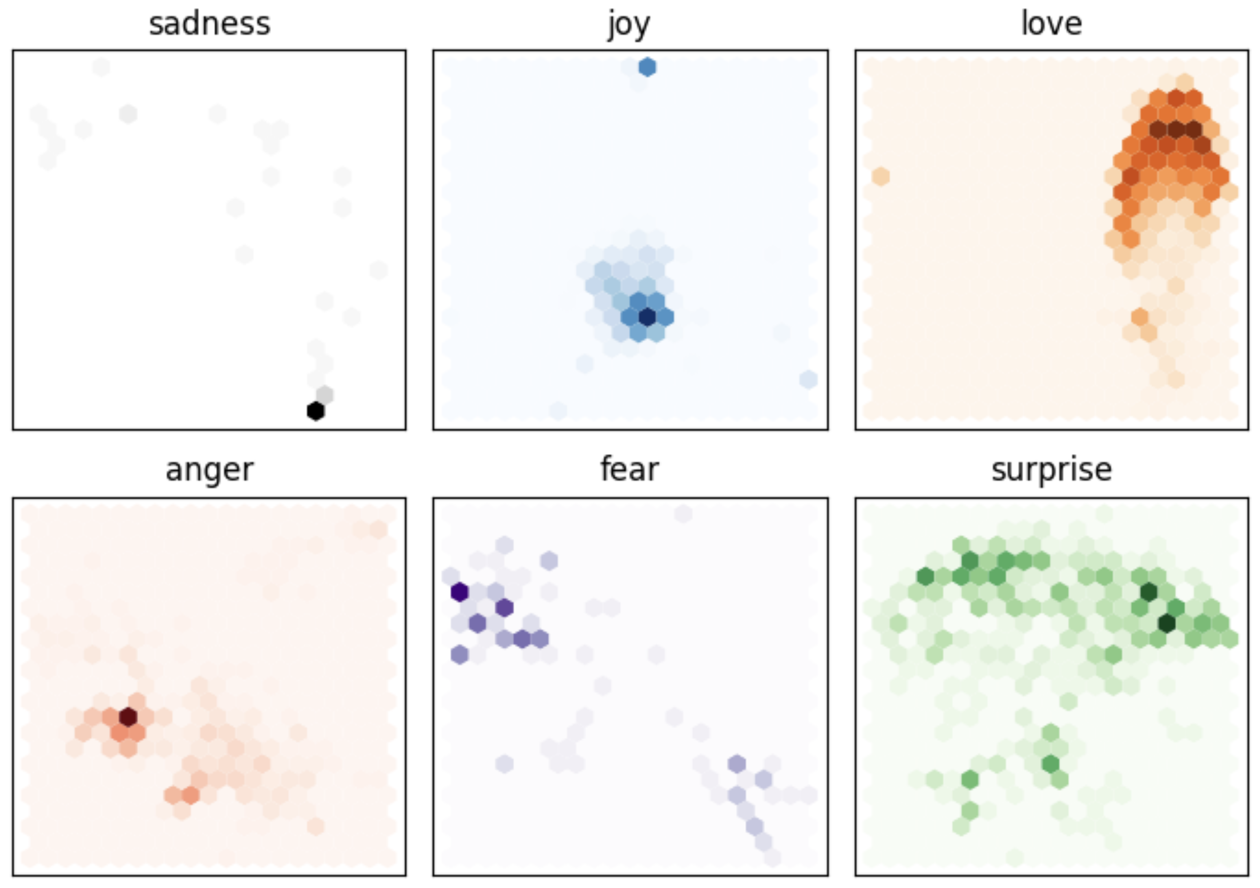

Original Data Logistic Regression

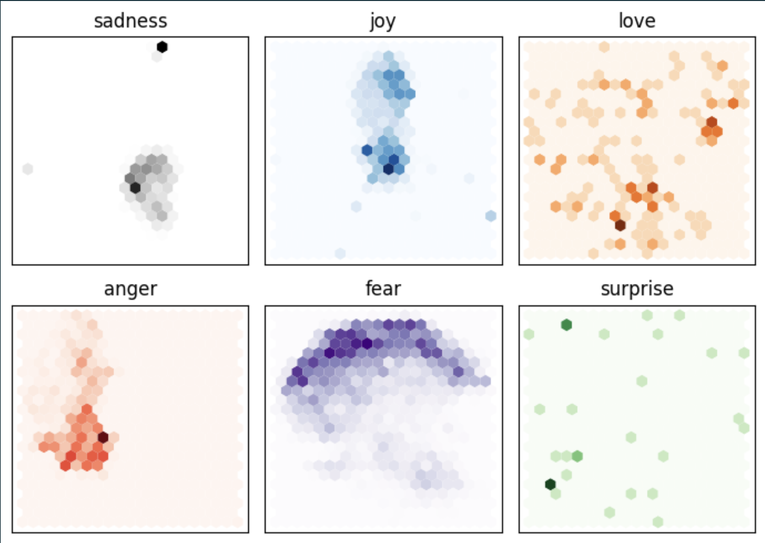 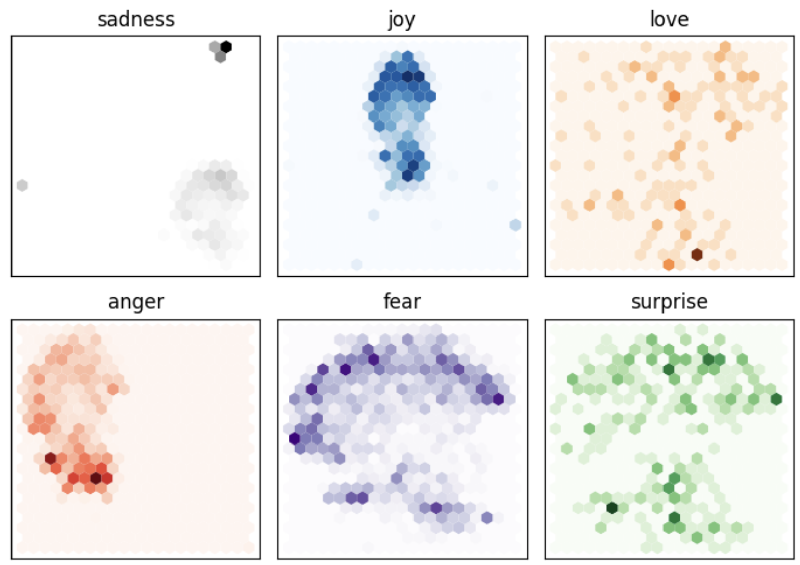

G MNB Fine Tuning

**Topic Modelling**

We conducted topic modelling to uncover and analyze the underlying themes present in discussions from the Reddit platform. This allowed us to extract meaningful patterns and topics that are prevalent in the vast array of text data related to individuals' experiences and discussions about testicular cancer.

**Methodologies Employed**

We utilized several techniques for our topic modelling analysis:

TF-IDF + LDA: We applied Term Frequency-Inverse Document Frequency (TF-IDF) combined with Latent Dirichlet Allocation (LDA) to identify topics. This approach helped us distinguish the importance of words within the documents, taking into account their frequency across the entire corpus to improve the quality of our topic extraction.

Topic 0:

celebrate posting signs marble noone nyu gyno usc ucla changing

Topic 1:

christmas merry catscan worsen suicide sunscreen lipoma jerk wank slap

Topic 2:

sending boxer toxicity strap brief jock yay wore briefs heck

Topic 3:

congrats man news great thats well luck hope amazing aint

Topic 4:

earn american movable hormones blank neoplasm testo upside whack descend

Topic 5:

awesome yeah dude happy hell buddy eat taste looks food

Topic 6:

brother update gl grade tried interpret inspiration afaik peabody uncle

Topic 7:

luck thank hear thanks glad updates appreciate king vaping everyone

Topic 8:

deleted ultrasound checked testicle urologist lump removed tc tell testicular

Topic 9:

chemo week year month well day say make start rplnd

BERTopic: Utilizing the capabilities of Bidirectional Encoder Representations from Transformers (BERT), BERTopic provided us with a modern approach to identifying topics. This deep learning method captures the contextual relationships between words, resulting in more coherent and distinct topic clusters.

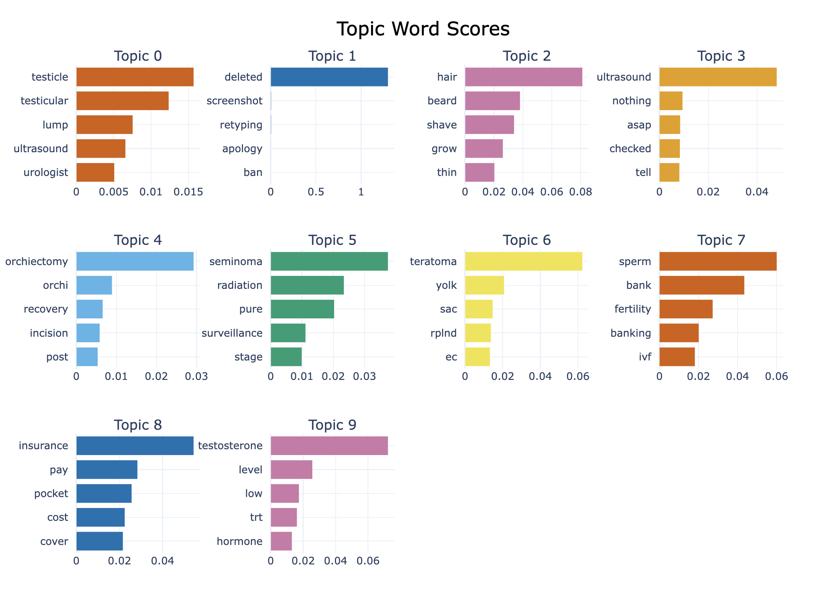

Kmeans + TFIDF: The K-means clustering algorithm, in conjunction with TF-IDF, was employed to group similar text entries together, further supported by the use of the Elbow Method to determine the optimal number of clusters.

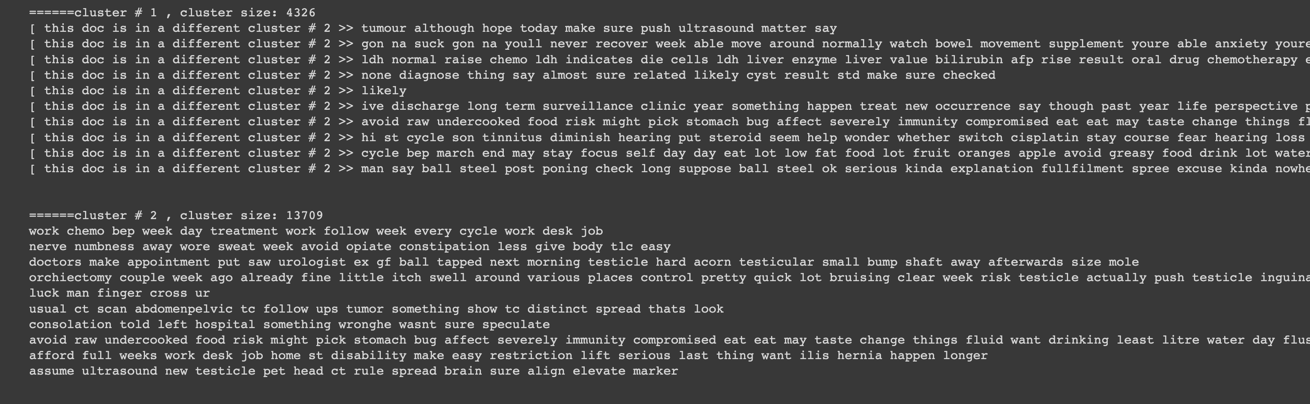

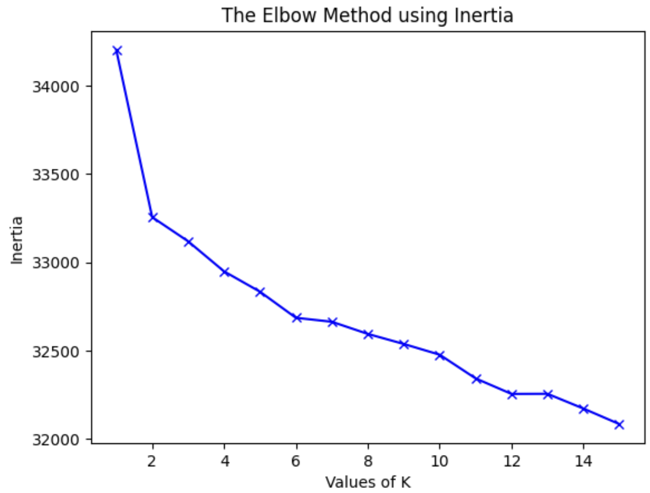

SBERT: Sentence BERT (SBERT) was used to generate sentence embeddings that capture semantic meanings, allowing for clustering of similar sentences to form well-defined topics related to testicular cancer discussions.

* Cluster #1: "Testicular Health Concerns and Ultrasound Experiences" - This cluster appears to discuss individuals' experiences with testicular health issues, including finding lumps, undergoing ultrasounds, and interactions with healthcare professionals regarding potential testicular cancer or related concerns.
* Cluster #2: "Post-Surgical Recovery and Side Effects" - The focus here seems to be on individuals sharing their experiences and advice regarding recovery after surgery, particularly for testicular cancer or related surgeries, including discussions about side effects and managing post-operative care.
* Cluster #3: "Testicular Cancer Diagnosis and Treatment Discussions" - This cluster likely contains conversations about the process of being diagnosed with testicular cancer, experiences with treatments, and the emotional and physical impacts of the disease.
* Cluster #4: "Support and Encouragement for Testicular Cancer Patients" - This cluster seems to be centered around providing support, sharing personal stories of encouragement, and discussing the emotional journey of those dealing with testicular cancer or related health issues.
* Cluster #5: "Testicular Cancer Treatment Options and Decision-Making" - The conversations in this cluster appear to revolve around the different treatment options for testicular cancer,decision-making processes regarding treatments, and discussions about the implications and outcomes of various treatment paths.

**Conclusion:**

Our project embarked on a multifaceted exploration of Reddit discussions related to testicular cancer, employing advanced machine-learning techniques to classify emotions and model topics within the online discourse.

The emotion classifier, refined through iterations and evaluations, can potentially gauge the emotional pulse of patient narratives and discussions. This aspect of the project helps us understand patient experiences on a large scale, offering insights into their emotional journeys that could guide patient support services.

Topic modelling gave us a clear picture of the main subjects people discuss, including health advice, emotional support, and healing journeys. The topics we uncovered give a full overview of the conversations happening, which is really useful for doctors, support groups, and those who make health policies.

The integration of emotion classification and topic modelling has not only provided a window into the collective mind and heart of individuals affected by testicular cancer but also paved the way for actionable insights that can enhance patient care and support systems. This approach promises to aid healthcare providers in understanding patient experiences, assist support groups in targeting their efforts, and inform researchers and policymakers about the community's needs.

**Ethics Statement:**

In the course of conducting our project, which involves mining insights from Reddit posts and discussions for emotion classification and topic modeling, we are committed to upholding the highest standards of ethical research. The following key principles guide our work:

**Privacy:** We recognize the importance of individual privacy. Therefore, all user data utilized in this project has to be anonymized to prevent the identification of individuals.

**Consent:** Our research exclusively employs data that is publicly available and has been collected in compliance with Reddit's terms of service. We respect the context of data sharing on the platform, acknowledging that users have not given explicit consent for secondary analysis. Thus, we handle the data with the utmost respect for the intentions of the users.

**Bias:** We acknowledge the potential for algorithmic bias in data analysis and model training. To mitigate this risk, we have implemented measures to ensure that our algorithms are as objective as possible. This includes balanced training data, regular audits for bias in our models, and transparent reporting of our methodologies and findings.

**LLM InfoBot:**

* Each chunk is converted into embeddings and stored in Pinecone vector db for optimized similarity seach
* When user query is received it computes the embeddings and with help of semantic search it queries Pinecone Vector db to get closest sentences
* It then ranks them in order and Gpt3.5 uses the context provided by ranked results to genetate an answer to user query

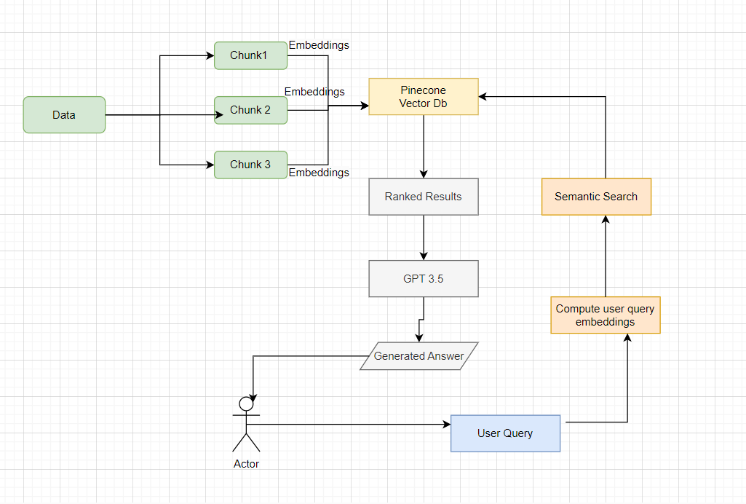

**Output:**

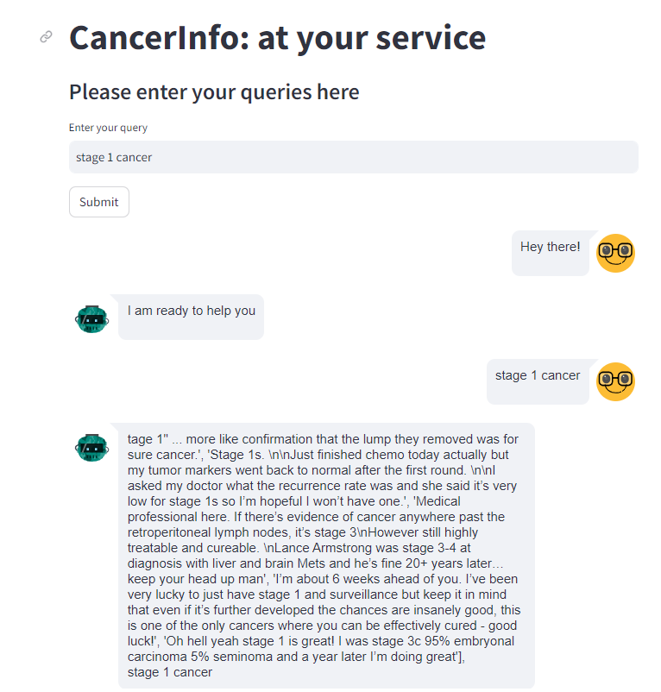

**THANK YOU.**